**Incident Response Playbook: Data Breach at Canadian Tire Financial Services**

__________________________________________________________________________

For my case study, I decided to research and use Canadian Tire Company.

**Company Information for Canadian Tire Corporation, Limited**

**1. Overview and Background**

* **Founded:** 1922
* **Headquarters**: Toronto, Ontario, Canada
* **Founder**: John William Billes and Alfred Jackson Billes
* **Company Type**: Public
* **Stock Symbol:** CTC.A (listed on the Toronto Stock Exchange)

**2. Business Operations**

* **Main Business Units**:
* **Canadian Tire Retail**: Largest business unit, offers a wide range of automotive, hardware, sports, and leisure products.
* **Canadian Tire Financial Services**: Provides financial products and services including credit cards, loans, and insurance.
* **Mark’s**: Specializes in casual and industrial wear.
* **Part Source:** Automotive parts and accessory specialty store.
* **Canadian Operations of Party City**: Retail chain specializing in party supplies and costumes.
* **Other Ventures**: Involvement in real estate and petroleum sectors through subsidiaries such as CT REIT and Canadian Tire Petroleum.

**3. Revenue and Financial Performance**

* **Annual Revenue:** Approximately $14.87 billion CAD (2020)
* **Employees**: Around 30,000 employees across all operations

**4. Market Position and Strategy**

* **Brand Recognition:** Recognized as one of Canada’s most iconic and trusted brands.
* **Business Strategy**: Focuses on innovation in retail experience and expansion of digital and e-commerce capabilities. Emphasis on customer loyalty programs and integrated multi-channel marketing strategies.

**5. Corporate Governance**

* **Board of Directors**: Comprised of experienced leaders from diverse sectors, ensuring broad oversight and strategic guidance.
* **Executive Team**: Led by a CEO, supported by executives managing finance, retail operations, marketing, and human resources.

**6. Sustainability and Social Responsibility**

* **Environmental Initiatives**: Commitment to reducing carbon footprint and improving environmental sustainability in operations and supply chain.
* **Community Engagement**: Active in community involvement through charity events, local sponsorships, and the Canadian Tire Jumpstart charity, which helps kids from financially disadvantaged families participate in sports and recreation.

**7. Technology and Innovation**

* **Digital Transformation**: Strong focus on leveraging technology to enhance customer experience both online and in-store. Initiatives include e-commerce expansion, mobile apps, and innovative retail technologies.
* **Research and Development**: Investments in R&D to stay ahead in product offerings and improve operational efficiencies.

**8. Risk Management**

* **Approach**: Comprehensive risk management framework addressing strategic, operational, financial, and compliance risks.
* **Cybersecurity Measures**: Significant investments in cybersecurity to protect sensitive customer and company data, especially critical for Canadian Tire Financial Services.

**2. Incident Type:** Significant Data Breach

**1. Incident Overview**

* **Description**: Unauthorized access and exfiltration of sensitive customer data, potentially including names, addresses, credit card details, and social security numbers.
* **Estimated Impact**: Thousands of customer records potentially compromised, posing risks of identity theft and financial fraud.

**2. Incident Specifics**

* **Type of Breach**: Combination of network intrusion and exploitation of system vulnerabilities that allowed unauthorized access to the financial services database.
* **Detection**: Discovered through anomaly detection tools that flagged unusual activity, including unauthorized access attempts and suspicious data outflows.

**3. Data Involved**

* **Sensitive Customer Information**: Full names, home addresses, transaction histories, credit card details, and social insurance numbers.
* **Internal Data**: Employee information, internal financial reports, and proprietary analytical data.

**4. Perpetrators**

* **Suspected Actors**: Cybercriminals, possibly part of an organized crime group, focusing on financial gain through data theft and sale on dark web markets.
* **Method of Attack**: Phishing attack targeting employees, leading to the installation of malware and subsequent exploitation of security weaknesses.

**5. Systems Affected**

* **Customer Database**: Central repository containing all customer financial data.
* **Communications Systems**: Email and internal messaging systems used to propagate the phishing attack.
* **Security Infrastructure**: Compromised to maintain unauthorized access over an extended period.

**6. Incident Discovery and Response**

* **Initial Detection**: Anomaly detection systems alerted the IT security team to unusual data extraction patterns.
* **Response Timeline**: Immediate action to isolate affected systems, followed by detailed forensic analysis to understand the breach scope and secure data endpoints.

**7. Potential Consequences**

* **Customer Impact**: Risk of financial loss and identity theft for affected customers, potentially leading to long-term trust issues with Canadian Tire Financial Services.
* **Regulatory and Legal Implications**: Potential fines and penalties under data protection laws such as PIPEDA and GDPR (for affected EU customers). Legal actions from customers and increased scrutiny from regulatory bodies.
* **Reputational Damage**: Negative media coverage and public perception impacting Canadian Tire's brand trust and customer loyalty.

**8. Prevention and Mitigation Strategies**

- **Pre-Incident**: Regular security audits, employee training on phishing and security best practices, and investment in advanced cybersecurity tools.

- **Post-Incident**: Strengthening of network security measures, additional employee training, and enhanced monitoring of sensitive data access. Implementation of more rigorous access controls and encryption protocols.

**3.Incident Discovery and Initial Response**

**1. Discovery**

* **Initial Detection Method**: The breach was initially detected by automated cybersecurity tools that monitor system and network anomalies. These tools flagged unusual patterns of data access and extraction that deviated from normal operational metrics.
* **Secondary Confirmation**: Upon initial detection, a manual review of system logs and security alerts by the IT security team confirmed unauthorized access attempts and unusual outbound data transfers.

**2. Alerting Protocol**

* **Immediate Escalation**: The IT security team immediately escalated the issue to key decision-makers, including the Chief Information Security Officer (CISO) and Chief Technology Officer (CTO).
* **Internal Alert System:** An internal crisis alert was triggered, mobilizing the Incident Response Team (IRT), which consists of members from IT security, legal, compliance, communications, and executive leadership.

**3. Initial Containment Efforts**

* **Network Isolation:** The affected systems, particularly those hosting sensitive customer data, were temporarily isolated to prevent further data exfiltration.
* **Traffic Monitoring**: Increase in monitoring network traffic to identify and block suspicious IP addresses and traffic patterns associated with the breach.

**4. Initial Impact Assessment**

* **Data Assessment**: Quick assessment to determine the types of data accessed, including the volume, sensitivity, and potential use of the compromised data.
* **Systems Assessment**: Review of all systems to check for any further signs of compromise, including other potential entry points not initially detected.

**5. Stakeholder and Regulatory Notifications**

* **Internal Communications**: Ongoing updates to all internal stakeholders to ensure that the management team was fully informed and prepared for further actions.
* **Regulatory Notification**: Preparation for mandatory notifications to regulatory bodies, such as the Office of the Privacy Commissioner of Canada, within the required timelines to comply with data breach laws.

**6. Public Relations and Customer Notification**

* **Initial Statement Preparation**: Drafting of an initial public statement to manage media inquiries and public reaction, ensuring it was ready to be issued once the breach was confirmed.
* **Customer Notification Strategy**: Developing a strategy for notifying affected customers, including the extent of the data breach, potential risks to them, and measures taken by Canadian Tire to address the incident. This strategy included direct communication channels like email alerts and dedicated hotlines.

**7. Coordination with External Experts**

* **Cybersecurity Experts**: Engagement of external cybersecurity experts to aid in forensic analysis and bolster containment and recovery efforts.
* **Legal and Compliance Advisors:** Consultation with legal teams to ensure all actions were compliant with relevant laws and to prepare for potential legal fallout.

**8. Documentation and Logging**

* **Incident Logging:** Detailed logging of all actions taken from the moment the breach was detected, for use in subsequent investigations and legal requirements.
* **Evidence Preservation:** Steps were taken to preserve evidence related to the breach for forensic analysis and potential legal proceedings.

Expanding on Stakeholder Communication for the incident response regarding the data breach at Canadian Tire Financial Services provides a detailed breakdown of how the organization would handle internal and external communications, ensuring transparency, accountability, and clarity throughout the crisis.

**4. Stakeholder Communication**

**1. Internal Communication Strategy**

* **Immediate Notification to Senior Management**: The incident response team promptly informs the CEO, CISO, CTO, and other senior executives about the breach details, impact assessment, and proposed response plan.
* **Regular Updates to Employees**: Communication via internal emails, intranet updates, and emergency meetings to keep employees informed and to prevent misinformation. Employees are also instructed on how to handle external queries about the breach.
* **Department-specific Briefings**: Tailored briefings for departments like customer service and finance, focusing on how the breach directly impacts their operations and how they should respond to customer inquiries.

**2. External Communication Strategy**

* **Press Releases**: Official statements released to the media to explain what happened, the potential impact on customers, and what actions are being taken by Canadian Tire.
* **Customer Notifications**: Direct communications to affected customers via email or mail, outlining the nature of the breach, what information was compromised, how it affects them, and the steps the company is taking to secure their data. This includes offering credit monitoring services to affected customers.
* **Social Media Management**: Utilizing social media platforms to manage public perception and provide updates as the situation progresses. Social media responses are coordinated by a dedicated team to ensure consistent and accurate messaging.

**3. Communication with Regulators**

* **Immediate Reporting to Regulatory Bodies**: The breach is reported to privacy commissioners and financial regulatory bodies in accordance with legal requirements, including detailed accounts of the incident, its scope, and the company’s immediate response.
* **Ongoing Updates**: Regular updates provided to regulatory bodies as new information becomes available or as milestones in the response plan are achieved.

**4. Communication with Other Stakeholders**

* **Investors and Analysts**: Special briefings for investors and financial analysts, particularly because Canadian Tire is a publicly traded company, to maintain market confidence. These communications emphasize the long-term strategies to mitigate risks and prevent future breaches.
* **Suppliers and Business Partners**: Informing suppliers and partners, especially those who might be impacted or could assist in resolving the breach. This helps in maintaining trust and collaborative efforts in strengthening security measures.

**5. Coordination and Consistency**

* **Central Communication Hub**: Establishing a central hub for all communications to ensure consistency in messaging across all channels and stakeholders. This hub also serves as the primary point for receiving feedback and monitoring public sentiment.
* **Spokesperson**: Designating official spokespersons for the incident, typically senior executives or the corporate communications head, who are trained to handle inquiries and present a unified corporate stance.

**6. Crisis Communication Training and Preparedness**

* **Pre-Crisis Training:** Regular training for key personnel on handling crisis communications, ensuring they are prepared to respond effectively under pressure.
* **Simulation Drills**: Conducting periodic simulation drills that include scenarios like data breaches, allowing the team to practice their roles and refine the communication strategy.

Expanding on the Technical Remediation and Recovery phase following a significant data breach at Canadian Tire Financial Services, this section outlines the steps taken to address the technical issues that allowed the breach, and the measures to prevent future incidents.

**5.Technical Remediation and Recovery**

**1. Immediate Technical Actions**

* **System Quarantine and Segmentation:** Immediate isolation of affected systems to prevent further data leakage. Systems are segmented to limit the spread of the breach and facilitate a more controlled investigation.
* **Password Resets and Access Control Revisions**: Mandatory reset of passwords and security credentials for all affected systems and users. Access controls are reviewed and tightened, implementing least privilege access principles to minimize exposure.
* **Patch Management**: Rapid deployment of patches to address the vulnerabilities that were exploited during the breach. This includes updates to both software and firmware that are identified as security risks.

**2. Root Cause Analysis**

* **Forensic Analysis**: Employing cybersecurity experts to perform a forensic analysis to determine how the breach occurred, including the identification of any malware used and the methods of data exfiltration.
* **Vulnerability Scanning and Penetration Testing**: Comprehensive scanning of the network and systems to identify and rectify vulnerabilities. Penetration testing by third-party security professionals to simulate future attacks and test the defenses.

**3. Data Recovery and Integrity Checks**

* **Data Restoration**: Recovery of data from backups, ensuring that they are free from any compromises. This includes restoring data to a secure environment and verifying its integrity.
* **Integrity Audits**: Conducting thorough audits to ensure that the restored data and other critical data within the network have not been tampered with or corrupted.

**4. Security Enhancements**

* **Implementation of Advanced Security Solutions**: Introducing more sophisticated cybersecurity measures such as intrusion prevention systems (IPS), advanced endpoint detection and response (EDR) tools, and real-time monitoring solutions.
* **Encryption Upgrades**: Strengthening data encryption both at rest and in transit to protect sensitive information from unauthorized access.
* **Zero Trust Architecture**: Moving towards a Zero Trust security model, where every user and device accessing the network is verified and monitored continuously.

**5. Long-Term Recovery and Monitoring**

* **Continuous Monitoring**: Establishing 24/7 monitoring of network traffic and system activities to detect and respond to anomalies immediately.
* **Security Awareness Training**: Rolling out extensive training programs for all employees focusing on cybersecurity best practices, phishing prevention, and safe data handling procedures.
* **Incident Response Plan Update**: Updating the incident response plan based on lessons learned from the breach. This includes refining communication protocols, technical response strategies, and recovery processes.

**6. Collaboration and Reporting**

* **Collaboration with External Experts**: Continuous engagement with cybersecurity firms and consultants to ensure that Canadian Tire remains updated on the latest security threats and mitigation strategies.
* **Compliance and Reporting**: Documenting all remediation steps and reporting to regulatory bodies as required by law. This documentation will also be used to inform stakeholders of the progress in strengthening security measures.

**7. Business Continuity Planning**

* **Review of Business Continuity Plans (BCP)**: Ensuring that the BCP is updated to reflect the new security protocols and systems in place. Testing the plan under simulated breach conditions to assess its effectiveness.
* **Disaster Recovery Simulations**: Regular simulations of different breach scenarios to ensure that all systems and processes function effectively under stress and that recovery times meet the organizational objectives.

Expanding on the Post-Incident Analysis and Reporting phase for Canadian Tire Financial Services after a significant data breach, this step is crucial for understanding what went wrong and ensuring that similar incidents are prevented in the future.

**6. Post-Incident Analysis and Reporting**

**1. Root Cause Analysis**

* **Forensic Investigation:** Engaging both internal security teams and external cyber forensics experts to conduct a thorough analysis of the breach. This includes tracing the source of the breach, the methods used by the attackers, and any system vulnerabilities that were exploited.
* **Timeline Reconstruction**: Building a detailed timeline of the breach from initial access to detection and containment. This helps in understanding the attackers' movements within the system and identifying any missed warning signs.

**2. Lessons Learned**

* **Identification of Weaknesses:** Identifying and documenting specific weaknesses in both technology and processes that allowed the breach to occur. This includes failures in security protocols, inadequate response times, and gaps in employee training.
* **Recommendations for Improvement**: Based on the weaknesses identified, developing a set of actionable recommendations to strengthen the security posture. These might include technical upgrades, changes in policy, or enhancements to monitoring and detection systems.

**3. Updating Policies and Procedures**

* **Incident Response Plan (IRP):** Revising the IRP to incorporate new tactics and strategies learned from the breach. Adjustments are made to improve response times, communication protocols, and the overall effectiveness of the response.
* **Security Policies:** Updating security policies to include stricter access controls, enhanced data protection measures, and regular security audits. Policies regarding remote access, password management, and device control are particularly scrutinized and strengthened.

**4. Compliance and Legal Reporting**

* **Regulatory Compliance**: Ensuring that all actions taken during and after the incident comply with relevant data protection laws and regulations. This includes mandatory breach notifications to affected individuals and reports to government and regulatory bodies.
* **Documentation for Legal Proceedings**: Preparing detailed reports and maintaining logs that might be required for legal actions, either from affected parties or regulatory agencies. This documentation includes evidence of compliance with regulatory requirements and the steps taken to mitigate the breach.

**5. Communication of Findings**

* **Internal Reporting**: Presenting a comprehensive report of the incident analysis, lessons learned, and recommendations to senior management and relevant stakeholders. This report is crucial for gaining support for necessary investments in security and changes in policy.
* **External Reporting:** Depending on legal and regulatory requirements, sharing findings and improvements with external stakeholders, including customers, to rebuild trust and demonstrate commitment to preventing future breaches.

**6. Employee Training and Awareness**

* **Enhanced Training Programs**: Developing new training modules that reflect the learnings from the incident, focusing on areas like recognizing phishing attempts, safe handling of sensitive data, and emergency response procedures.
* **Awareness Campaigns**: Launching company-wide awareness campaigns to keep security at the forefront of employee responsibilities. This includes regular updates on new security protocols and reminders of best practices.

**7. Ongoing Monitoring and Review**

* **Continuous Improvement**: Establishing a routine for ongoing review and continuous improvement of security measures. This includes regular audits, penetration testing, and revisiting the incident response playbook to make adjustments based on new threats and vulnerabilities.
* **Performance Metrics**: Setting up metrics to measure the effectiveness of implemented changes and the overall resilience of the organization against cyber threats. Monitoring these metrics helps in identifying areas that need further improvement.

**Flowchart Playbook**

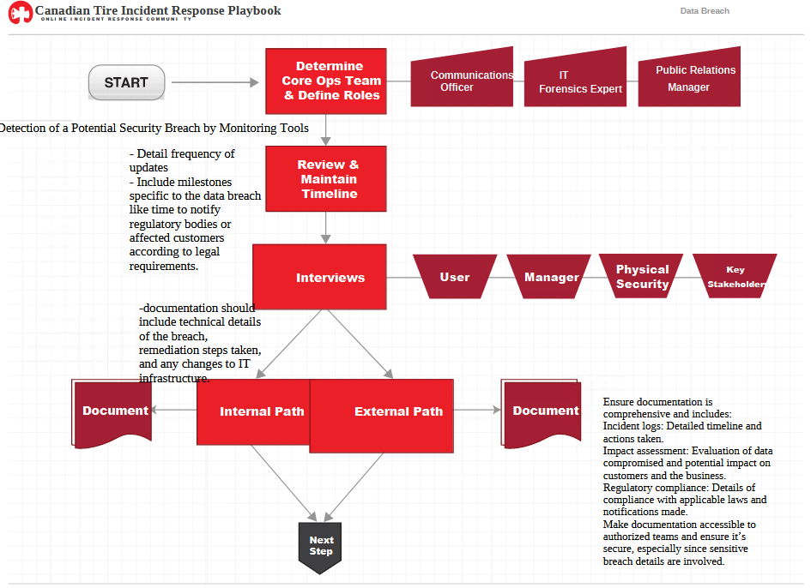

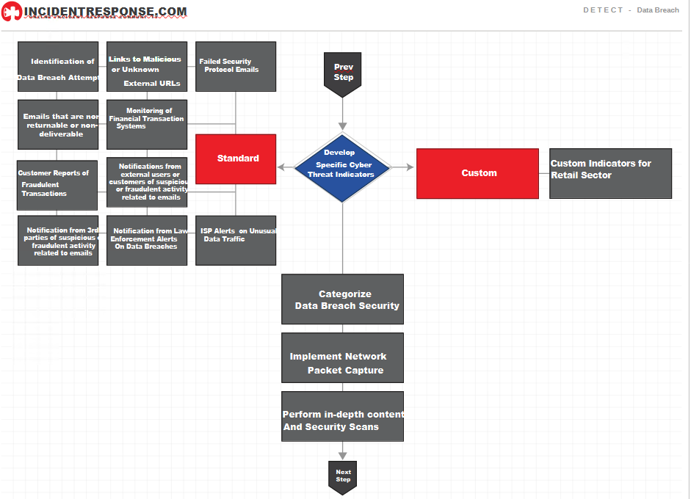

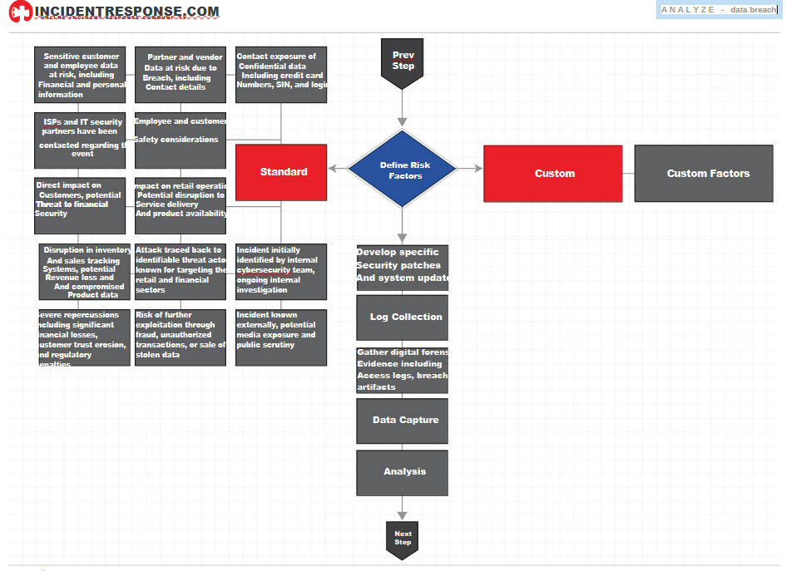

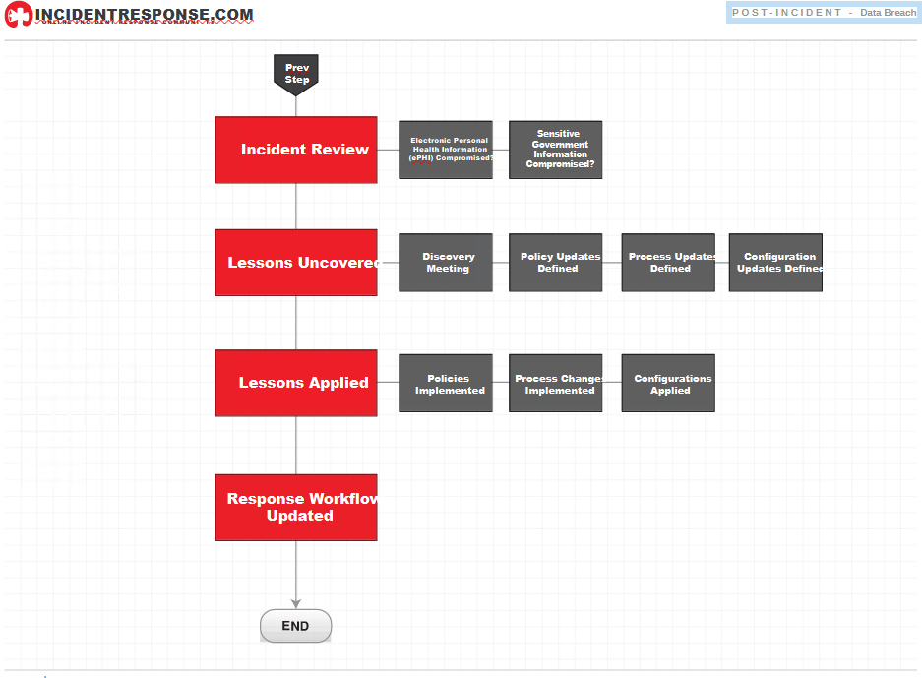

**Policy**

**1. User Information Capture and Monitoring Policy**

**Purpose**: To ensure that all user information captured through Canadian Tire’s network monitoring or packet capture tools is handled securely and ethically, maintaining privacy and compliance with legal standards.

**Scope**: This policy applies to all systems and personnel involved in the monitoring and capturing of user data across Canadian Tire’s network.

**Policy**:

* All data captured will be classified according to its sensitivity and handled accordingly.
* Only authorized personnel will have access to this data, and it will be used solely for the purpose of security monitoring and incident response.
* Regular audits will be conducted to ensure that all data capture tools comply with this policy and legal requirements.

**2. Personal Identifiable Information (PII) Access and Dissemination Policy**

**Purpose**: To control and monitor the access and dissemination of PII within Canadian Tire to prevent unauthorized use and ensure data integrity and privacy.

**Scope**: This policy covers all employees and contractors who may have access to PII stored in Canadian Tire’s databases.

**Policy**:

* Access to PII will be granted based on the principle of least privilege, and users will only be given access to the data necessary for their job functions.
* Any dissemination of PII outside the organization must be approved through a formal process that includes a review of the justification for dissemination and the security measures in place to protect the data.
* Breaches of this policy must be reported immediately to the Data Protection Officer.

**3. Traffic Light Protocol (TLP) Compliance Policy**

**Purpose**: To ensure that sensitive information categorized under the Traffic Light Protocol (TLP) is handled and communicated within Canadian Tire in a secure and compliant manner.

**Scope**: This policy applies to all Canadian Tire employees and partners who handle information categorized under the TLP.

**Policy**:

* Information labeled TLP RED must not be disclosed outside of persons directly involved in the incident without explicit permission from the information owner.
* All employees must receive training on the TLP guidelines and their responsibilities regarding the handling of TLP-classified information.
* Violations of TLP handling procedures will result in disciplinary actions and could lead to legal consequences.

**4. Data Retention and Destruction Policy**

**Purpose**: To define the periods for which various types of data are retained at Canadian Tire and the methods for securely destroying data that is no longer needed.

**Scope**: This policy covers all data held by Canadian Tire, whether digital or physical.

**Policy**:

* Data retention periods will be established based on legal requirements and the operational needs of Canadian Tire.
* All data slated for destruction will be destroyed in accordance with industry standards for secure data destruction.
* Periodic reviews will be conducted to ensure that data is not retained beyond its designated period unless required by law or necessary for legitimate business purposes.

**5. Log Retention Policy**

**Purpose:** To manage the creation, retention, and destruction of logs created by Canadian Tire’s information systems and to ensure these logs are available for audit, review, and incident handling.

**Scope**: This policy applies to all information systems that create logs at Canadian Tire.

**Policy**:

* Logs will be retained for a minimum period dictated by regulatory requirements and Canadian Tire’s internal policies.
* Log access will be restricted to authorized personnel, and logs will be protected from unauthorized alteration or deletion.
* Procedures will be established for the review and analysis of logs as part of regular audits and in response to security incidents.

**Citations**

1. Durham College. (2024). Governance Policies. Durham College.<https://durhamcollege.ca/about/governance/policies>
2. IncidentResponse.com. (2023). Phishing Incident Response Template. I used this template to make my data breach playbook. <https://www.incidentresponse.com/templates/phishing-response>
3. Canadian Tire Corporation. (2023). About Us. Canadian Tire. <https://corp.canadiantire.ca/English/about-us/default.aspx>